Project Planning Phase

Project Planning Template (Product Backlog, Sprint Planning, Stories, Story points)

Date | 18 October 2022
Team ID | PNT2022TMID31937
Project Name | Project - Retail Store Stock Inventory Analytics
Maximum Marks | 8 Marks

Product Backlog, Sprint Schedule, and Estimation (4 Marks) Use the below template to create product backlog and sprint schedule
 | Functional | User Story
Sprint | Requirement | User Story | User Story / Task | Story Points | Priority | Team
Sprint | Requirement | Number
 | (Epic) | Number |  |  |  | Members
 |  |  | As a user, I can register for the |  |  | Mohammed Muzakeer M
Sprint-1 | Registration | USN-1 | application by entering my email, | 10 | High | Vishal D
 |  |  | password, and
 |  |  | confirming my password.
Sprint-1 |  | USN-2 | As a user, I will be uploading my | 10 | High | Abhirami B
Sprint-1 | Data uploading
 | Data uploading |  | data intothe Cognos analytics

 | Functional | User Story
Sprint | Requirement | User Story | User Story / Task | Story Points | Priority | Team Members
Sprint | Requirement | Number
 | (Epic) | Number
 |  |  |  |  |  | Janani R
Sprint-2 |  | USN-3 | As a user, I will be performing analysis on | 5 | High
Sprint-2 | Data Analysis | USN-3 | the data for making predictions | 5 | High
Sprint-2 | Dashboards | USN-4 | As a user, I will be making visualizations | 10 | High | Vishal D  Abhirami B
 | Dashboards |  | and interactive dashboards from the data
Sprint-3 | Story | USN-5 | As a user, I will be making stories from the | 20 | High
Sprint-3 | Story | USN-5 |  | 20 | High | Mohammed Muzakeer M  Vishal D
 |  |  | data and the dashboards |  |  | Mohammed Muzakeer M  Vishal D
 | Report |  | As a user, I will be making a report from the |  |  | Mohammed Muzakeer M
Sprint-4 | Report | USN-6 | analysis and dashboards | 20 | High | Janani R

Project Tracker, Velocity & Burndown Chart: (4 Marks)

Sprint | Total Story | Duration | Sprint Start Date | Sprint End Date | Story Points | Sprint Release Date
 | Points |  |  | (Planned) | Completed (as on | (Actual)
 |  |  |  |  | Planned End
 |  |  |  |  | Date)
Sprint-1 | 20 | 6 Days | 24 Oct 2022 | 29 Oct 2022 | 20 | 29 Oct 2022
Sprint-2 | 20 | 6 Days | 31 Oct 2022 | 05 Nov 2022 | 20 | 05 Nov 2022
Sprint-3 | 20 | 6 Days | 07 Nov 2022 | 12 Nov 2022 | 20 | 12 Nov 2022
Sprint-4 | 20 | 6 Days | 14 Nov 2022 | 19 Nov 2022 | 20 | 19 Nov 2022

Velocity:

Imagine we have a 10-day sprint duration, and the velocity of the team is 20 (points per sprint). Let’s calculate the team’s average velocity (AV) per iteration unit (story points per day)
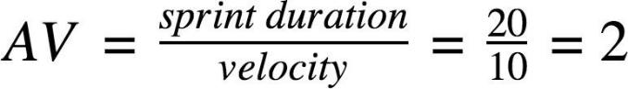

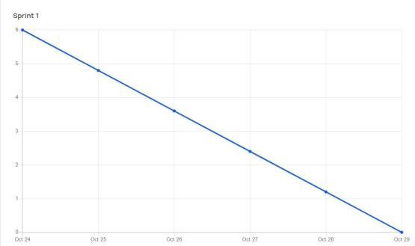
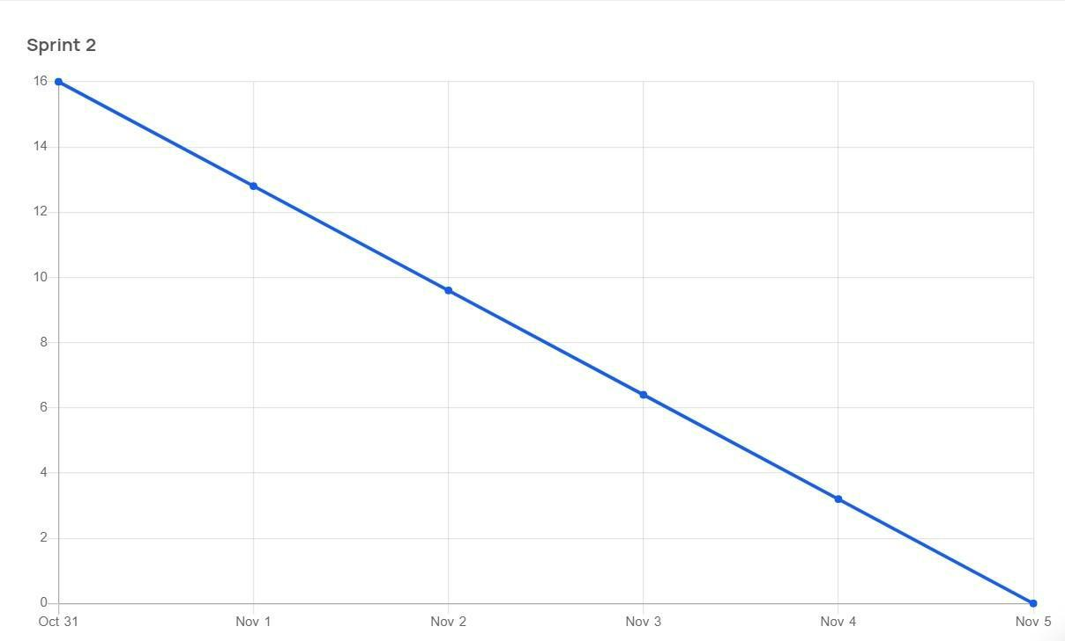
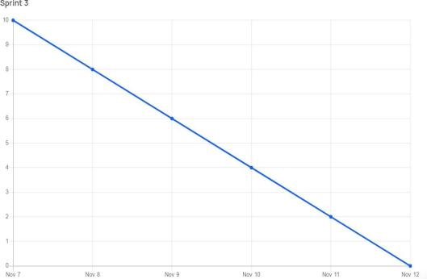
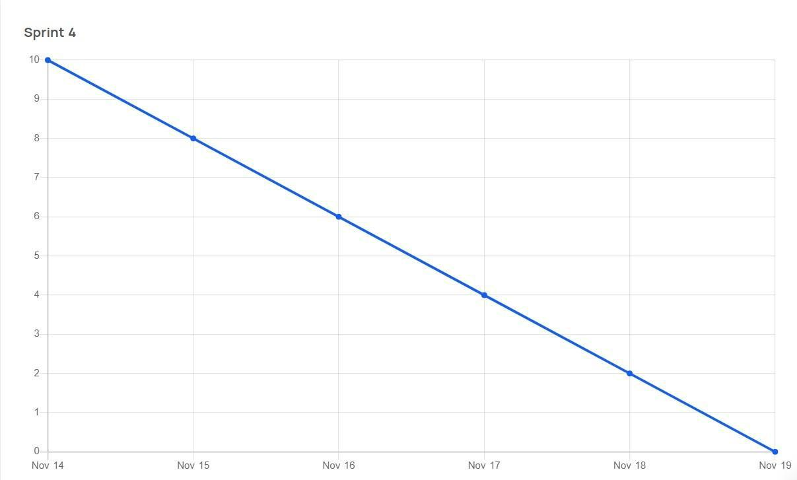
Burndown Chart: A burn down chart is a graphical representation of work left to do versus time. It is often used in agile software development methodologies such as Scrum. However, burn down charts can be applied to any project containing measurable progress over time.

